Lim, Francis Raemark L.

Monoso, Jose Miguel D.

Screenshots:

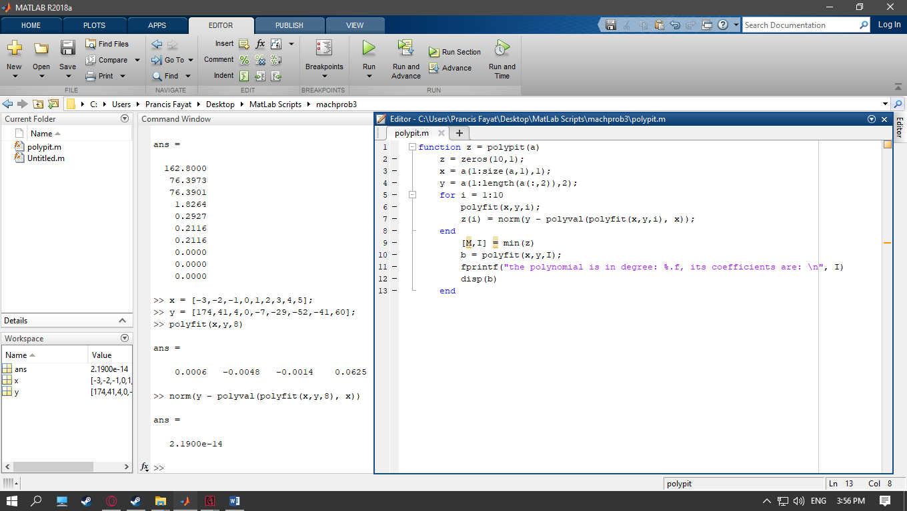

Testing:

Problem 3 of Programming assignment no. 4:

Given points (-3,174), (-2,41), (-1,4), (0,0), (1,-7), (2,-29), (3,-52), (4,-41), (5,60)

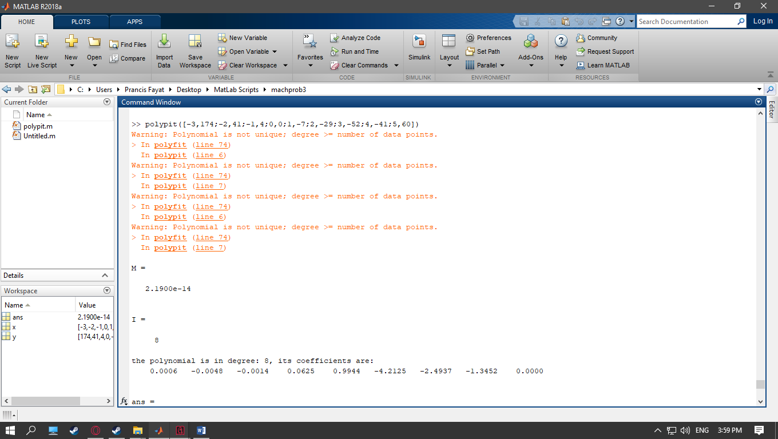

Therefore the polynomial is: 0.0006x^8 - 0.0048x^7 - 0.0014x^6 + 0.0625x^5 + 0.9944x^4 - 4.2125x^3 - 2.4937x^2 - 1.3452x

Plotting in desmos graphing calculator we get:

